Guidance for reviewing an EHC Plan

School, college or setting procedures for reviewing an EHC Plan

The Local Authority must arrange for a review of a child or young person’s EHC Plan at least annually. The first review must be held within 12 months of the date of the issue of the EHC Plan.
The responsibility for organising and facilitating the meeting should be undertaken by the school, college or setting which the child or young person attends. Early years settings will organise and facilitate the meeting but will be able to refer to their Area SENCO from the Early Years Support Team for advice and support. The school, college or setting must:
- Convene the EHC Plan review and along with relevant school/setting staff and invite the following to attend with at least two weeks notice of the date of the meeting:

  - the child or young person
  - the child’s or young person parents/carers
  - a representative from the Local Authority Special Education Service
  - involved education, health and care professionals

- Seek advice and information from every one invited to the review meeting about the child or young person’s progress towards achieving the outcomes specified in the EHC Plan review and any other matters relating to their progress and circulate this to everyone invited to the review meeting at least two weeks before the meeting.

- Review the child or young person’s progress towards achieving the outcomes specified in the EHC Plan and to make recommendations on what changes might need to be made to those outcomes and/or their support (including support provide through a Personal Budget) to help them achieve them.

- Consider the continuing appropriateness of the EHC Plan in the light of the child or young person’s progress during the previous year or changed circumstances and whether changes are required

- Set new targets for the coming year and where appropriate, agree new outcomes

- Prepare and send a report of the review meeting to everyone invited to the meeting within 2 weeks of the meeting.

A person centred review process

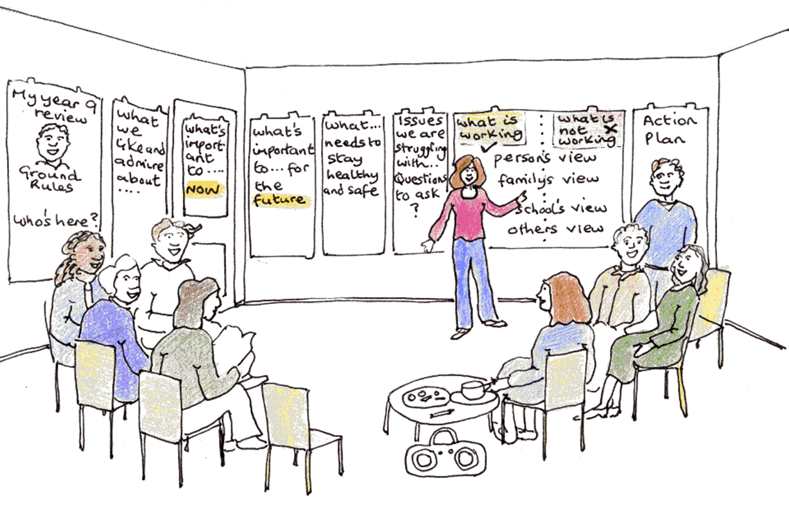
A person centred review is a radically different type of meeting from the conventional annual review meeting in that it strives to place the child or young person and their family at the centre of the meeting process.

It does this by using a positive focus for reviewing the child or young person’s progress by starting with ‘what people like and admire about the child or young person’ as well as sharing ‘good things have happened since the last review’.

However, this review of progress is equally pragmatic in that it goes on to look at ‘what is working’ as well is ‘what is not working’ from the perspective of the child or young person, family, school/setting and others. The meeting concludes with a consideration of ‘what is important to the child or young person’ both now and in the future with respect to better life outcomes and a final section which addresses questions to answer and issues to be resolved. This is then carried forward into action planning as part of the next Implementation Plan.

This person centred review of progress supports the usual review decision making where recommendations need to be made to the Local Authority about maintaining, amending or ceasing to maintain the Plan (see section 3 of the EHC Plan review meeting proforma):

The format and feel of a person centred review is also radically different in that it is much more informal, interactive and visual. Where appropriate, the child or young person begins by providing their views and this usually works best as part of a prepared presentation. This information can be recorded on flipchart paper arranged around the room and then participants are then invited to contribute their views under each of the review headings after which actions and the planning to further support the child or young person’s progress towards their outcomes is agreed (see section 4 of the EHC Plan review meeting proforma)

A further major difference is the change in role from the person who previously chaired the meeting to someone who now acts as a facilitator with the aim of supporting the child or young person and the family to participate in the meeting.

Actions for the facilitator

Preparing for the review

- Ensure that the date is set with the family and that relevant setting/school staff and professionals are invited with at least 2 weeks notice
- Seek advice and information from every one invited to the review meeting and circulate this to all attendees at least 2 weeks before the meeting
- Support the child or young person to prepare their views (ie, good things that have happened since the last review, what is working well and what is not working well, what’s important now and what is important in the future). This presentation can take a variety of forms.
- Prepare the report on the child or young person’s progress towards their outcomes including targets and actions agreed from the current Implementation Plan. Gather the appropriate data to report the child or young person’s National Curriculum progress in the core subjects in terms of sublevels achieved since the previous review (see section 2b of the EHC Plan review meeting proforma)
- Have copies of the EHC Plan and previous Implementation plan available
- Prepare and arrange the room in such a way to help the child or young person and the family to feel comfortable and so as to support their participation (eg, display examples of the child or young person’s work, refreshments, etc).
- Place the following headings on flip chart paper around the room

Good things that have happened since the last review
What we like and admire about …….
Who’s at the meeting

What’s working What’s not working

Child
Family
School
Others

Important now Important for the future

Good Health
Education, learning and work
Independent living
Friends, relationships and community

Review of the EHC Plan (section 3, EHCP AR proforma)
Questions to answer / issues to resolve

Implementation planning for EHC Plan outcomes (section 4 - EHCP AR proforma)
Outcomes | Targets | Support | Monitoring

Planning for any other actions

Running the review
- The facilitator welcomes participants to the meeting and invites them to complete their details on the ‘Who’s here’ sheet and to make a contribution to the ‘What we like and admire’ sheet.
- The facilitator begins the meeting by asking everyone to introduce themselves and to say who they are and their relationship to the child or young person.
- The facilitator can then share what has been recorded on the ‘What we like and admire’ sheet’ as well as add any further contributions
- The facilitator explains the purpose of the meeting and introduces the ground rules

The purpose of the meeting is to:

- Review the child or young person’s progress towards achieving the outcomes specified in the EHC Plan
- Consider the continuing appropriateness of the EHC Plan and to recommend any changes to this that might be necessary
- Set new targets for the coming year

and to do this in a person centred way focusing on positives about the child and their progress as well as looking at what is working and not working from the point of view of the child or young person, family, school/setting and others. This concludes with a consideration of what is important to the child or young person both now and in the future with respect to better life outcomes and remaining questions to answer and issues to be resolved. This is then carried forward into action planning as part of the next Implementation Plan.

The ground rules for meeting should include the following:

- Everyone’s view is valuable
- There is no such thing as a silly question
- No jargon
- Mobiles switched off or onto silent
- Don’t worry about spelling mistakes
- Don’t interrupt
- 5 minute rule
- Respect confidentiality

- The facilitator then invites the child or young person to make their contribution
- The facilitator then facilitates discussion working through each review heading in turn
- The facilitator (or an assistant) records the key points from the discussion under each heading.
- At the conclusion of each section, the facilitator should check to ensure that everyone’s views have accurately been recorded.
- When it comes to reviewing the EHC Plan, the facilitator should ensure that copies of this are made available and that changes are either recorded in section 3 of the EHC Plan review meeting proforma or directly onto a copy of the EHC Plan.
- Where the child or young person has just moved into a new stage/phase, please advise on new outcomes to support the child or young person to make a successful transition to the next stage or phase. For young people in Y9 and above, outcomes should focus on preparing for adulthood.
- Any request for a Personal Budgets by parents/carers or a young person (16+) should be recorded under the relevant section of the EHC Plan review proforma.
- Where there is a difference in view as to what changes should be recommended to the EHC Plan, then the different views should be recorded making it clear who is saying what.
- The meeting then goes on to complete the next implementation plan to include targets, support and monitoring to enable the child or young person work towards their outcomes over the coming year as well as any other agreed actions (including any in relation to questions and/or issues recorded under the ‘Questions to answer/Issues to resolve’ flip chart heading).
- The final part of the meeting is to review the ongoing requirements for SEND transport where this has been agreed on SEND grounds. The meeting will need to provide a clear recommendation regarding this.

Children or young people with SEND will receive SEND transport where they live further than the statutory distance from their school (statutory distance is defined as 2 miles for a child under 8 years of age and 3 miles for a child aged 8 and older). Some children or young people with SEND who live within the statutory distance from their school will receive SEND transport based on SEND needs, ie:

- Long term severely restricted independent mobility due to physical disability or a medical condition resulting in severe persistent pain and/or extreme fatigue
- Long term restricted mobility due to a medical condition resulting in serious persistent health and safety risks
- Impairment resulting in severely restricted oral communication
- Severely restricted mobility due to a sensory impairment
- Cognitive abilities within the range associated with severe learning difficulties
- Severe behavioural emotional and/or social difficulties in comparison with other children of their age

(Please refer to Leicester City’s Home to School Transport Policy for children with SEN/Disability/Mobility Needs March 2010 for further information).

Where SEND transport has been agreed for an individual child or young person on SEND grounds, this discussion should plan for and review the outcomes from appropriate independence travel training where this has been arranged.
Actions following the review

- All sheets are collated for typing
- Prepare and send a report (using the EHC Plan review proforma) of the review meeting to the Local Authority and everyone invited to the meeting within 2 weeks of the meeting.
- Ensure that the Implementation plan is actioned

Reviews of EHC Plans for children aged 0-5

The Local Authority must arrange for a review of an EHC Plan for a child under five at least every three to six months to ensure that the provision continues to be appropriate.

Reviews of EHC Plans for young people aged 14+

The review of an EHC Plan of a young person in the school year in which they turn 14 years of age (Year 9) and every review thereafter must include a focus on preparing for adulthood including employment, independent living and participation in society. This transition planning must be built into EHC Plans and where relevant should include effective planning for young people moving from children’s to adult care and health services. Planning must be centred around the individual and explore the young person’s aspirations and abilities and what they want to be able to do when they leave post-16 education or training and the support they need to achieve their ambition.

In order to support this focus on preparation for adulthood, a new role of a Plan Co-ordinator (in addition to the facilitator) is introduced to the EHC Plan review at year 9 and every review thereafter. This is a person who has relevant knowledge about preparing for adulthood including employment, independent living and participation in society and they will have a specific role, in liaison with the young person and/or family, to chase up actions with professionals that have been agreed as part of the EHC Implementation Plan.

There is also a different format for the EHC Implementation Plan (see EHC 14+ Implementation plan - appendix 9.5) and this should be used at the 14+ review and every review thereafter.

Transfer between phases of education
A review of an EHC Plan involving a transfer between EYs settings and/or schools (eg, an early years setting to school, infant to junior, primary to secondary) including the Local Authority administrative procedures should be completed by the 15th of February in the calendar year of the transfer. For young people transferring from secondary to a post 16 setting, the review process should be completed by 31st of March in the calendar year of the transfer or at least 5 months before the transfer takes place.
Local Authority administrative procedures for reviewing an EHC Plan

The Local Authority should inform schools, colleges and settings at least 2 weeks before the beginning of each term of children and young people with EHC Plans who are due to have a review that term. This information should also be provided to health and social care and should indicate which children and young people are due to transition because of a change of school, college or setting.
Within 4 weeks of the review meeting, the Local Authority must decide whether to it proposes to maintain, amend or cease to maintain the plan and to notify the child’s parents/carers or young person and the school/setting which the child or young person attends.
The Local Authority should also inform parents/carers or the young person of their right of appeal, the time limits for doing so and about disagreement resolution, mediation and SENDIASS services.
Where the child or young person does not attend a school or setting, then the Local Authority will make the arrangements to organise and convene the EHC Plan review.

Amending, reassessing and ceasing to maintain EHC Plans

Amending an EHC Plan

Where the Local Authority proposes to amend a plan, it must send the parent/carer or young person a copy of the existing (non-amended) plan and an accompanying notice providing details of the proposed amendments, including copies of any evidence to support the proposed changes. The parent or young person should be informed that they may request a meeting with the Local Authority to discuss the proposed changes. The parent or young person must be given at least 15 days to comment and make representations on the proposed changes.

Following representations from the parent or young person, if the Local Authority decides to continue to make amendments, it must issue the amended plan within eight weeks of the original amendment notice. If the Local Authority decides not to make the amendments, it must write to the parents or young person explaining why within the same time limit.

When the plan is amended, the new plan should state that it is an amended version of the plan and the date on which it was amended, as well as the date of the original plan. Additional advice and information, such as the minutes of a review meeting and accompanying reports, which contributed to the decision to amend the plan, should be appended in the same way as advice received during the original assessment. The amended plan should make clear which parts have been amended.

When sending the final amended plan, the Local Authority must notify the parent/carer or young person of their right to appeal, the time limits for doing so, the requirement to consider mediation, and inform them about disagreement resolution and SENDIASS services.

Reassessing an EHC Plan

The Local Authority must conduct a reassessment of a child or young person’s EHC Plan if this is requested by the child’s parent/carer, young person, the school/setting that the child or young person attends or a relevant education, health or care professional/agency unless:

- this is within 6 months of the last assessment being conducted
- and/or the Local Authority considers that this is not necessary (eg, that it considers that the child or young person’s needs have not changed significantly).

Where the Local Authority decides it does not need to re-assess a child or young person, it must notify the child’s parent or the young person within 15 days of receiving the request to reassess and must notify them of their right to appeal, the time limits for doing so, the requirement to consider mediation, and inform them about disagreement resolution and SENDIASS services.

The process for re-assessment will be the same as the process for a first assessment except that the overall maximum timescale for a re-assessment from the point of agreeing an assessment to issuing the final plan is 14 weeks.

Ceasing to maintain EHC Plans

The Local Authority can cease to maintain an EHC Plan where:

- It is no longer responsible for the child or young person, eg, if they have moved to another Local Authority
- It decides that special educational provision is no longer needed
- A young person aged 16 or over takes up paid employment (including employment with training but excluding Apprenticeships)
- The young person enters Higher Education
- A young person aged 18 or over leaves education and no longer wishes to engage in further learning.

Where a Local Authority is considering ceasing to maintain a child or young person’s EHC Plan it must:

- Inform the child’s parent or the young person in writing
- Consult the child’s parent/carer or the young person
- Consult the school or other institution that is named in the EHC Plan

Where, following the consultation, the Local Authority decides to cease to maintain the child or young person’s EHC Plan, it must notify in writing the child’s parent or the young person and the institution named in the child or young person’s EHC Plan, of that decision.

Where the child’s parent or young person disagrees with the Local Authority’s decision to cease their EHC Plan, they may appeal to the Tribunal. The Local Authority must continue to maintain the EHC Plan until the time has passed for bringing an appeal or, when an appeal has been registered, until it has been resolved.

